Twin County 9-1-1
Regional Commission

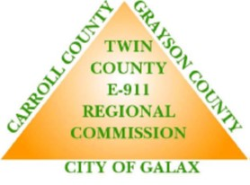

Request for Proposals
(RFP 2021‐Radio System)

Public Safety Voice Radio Communications System
ADDENDUM 1.2
DUE: MARCH 31, 2022; 2 PM EST

RFP SCHEDULE CHANGE
The schedule shown below supersedes the schedule included in Section 1.3 of the original RFP as well as Addeundum 1.

ACTIVITY | DATE
Publish Request for Proposal and Functional Specifications to Jurisdiction Websites; Advertise in local paper | November 12, 2021
Deadline – Offerors required to notify Commission of plans to attend Pre‐Bid Conference. | November 26, 2021
Deadline – To submit written questions for the Pre‐Bid Conference. | December 31, 2021
Pre‐Bid Conference | December 9, 2021  January 12, 2022, 10 AM
Site Visits | See Addendum 1,2 Section 1.2
Deadline to Submit Questions | December 23, 2021  February 10, 2022
Commission Deadline to Respond to Questions | January 7, 2022  March 3, 2022
Deadline – To Submit Proposal | February 18, 2022 before 2 PM  March 31, 2022 before 2 PM
Proposal Evaluations | March 11, 2022  April 14, 2022
Interviews and Presentations with highest scoring vendors | March 30, 2022  May 7, 2022
Contract Negotiations | June 30, 2022
Contract Presented To Board of Supervisors / Signed | After July 1, 2022

SITE VISITS
To make site visits manageable for the limited local resources, vendors are invited to participate on the following dates: January 11, January 12 (immediately following the pre-bid), and January 13. Currently, there will be two groups. Please send an email to Jolena Young at jyoung@galaxva.com with the number of participants. A four-wheel drive is recommended.

